HoangYen Nguyen

08/03/2022

Assignment 04

Screen cap for blank field errors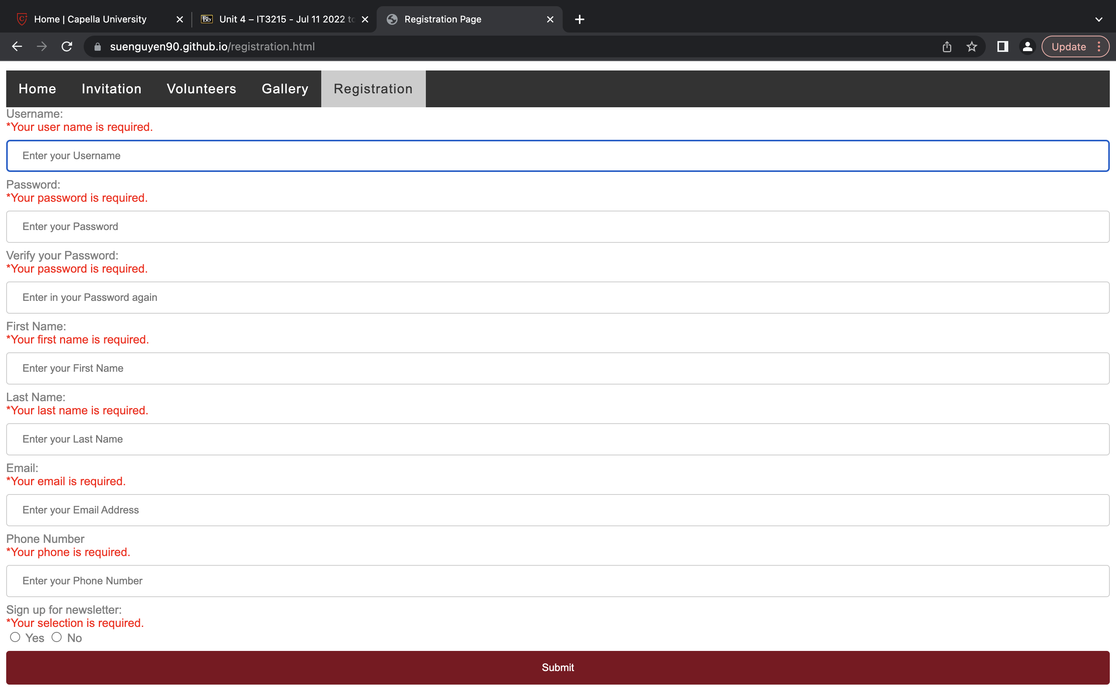

Screen cap for specified requirements for input fields

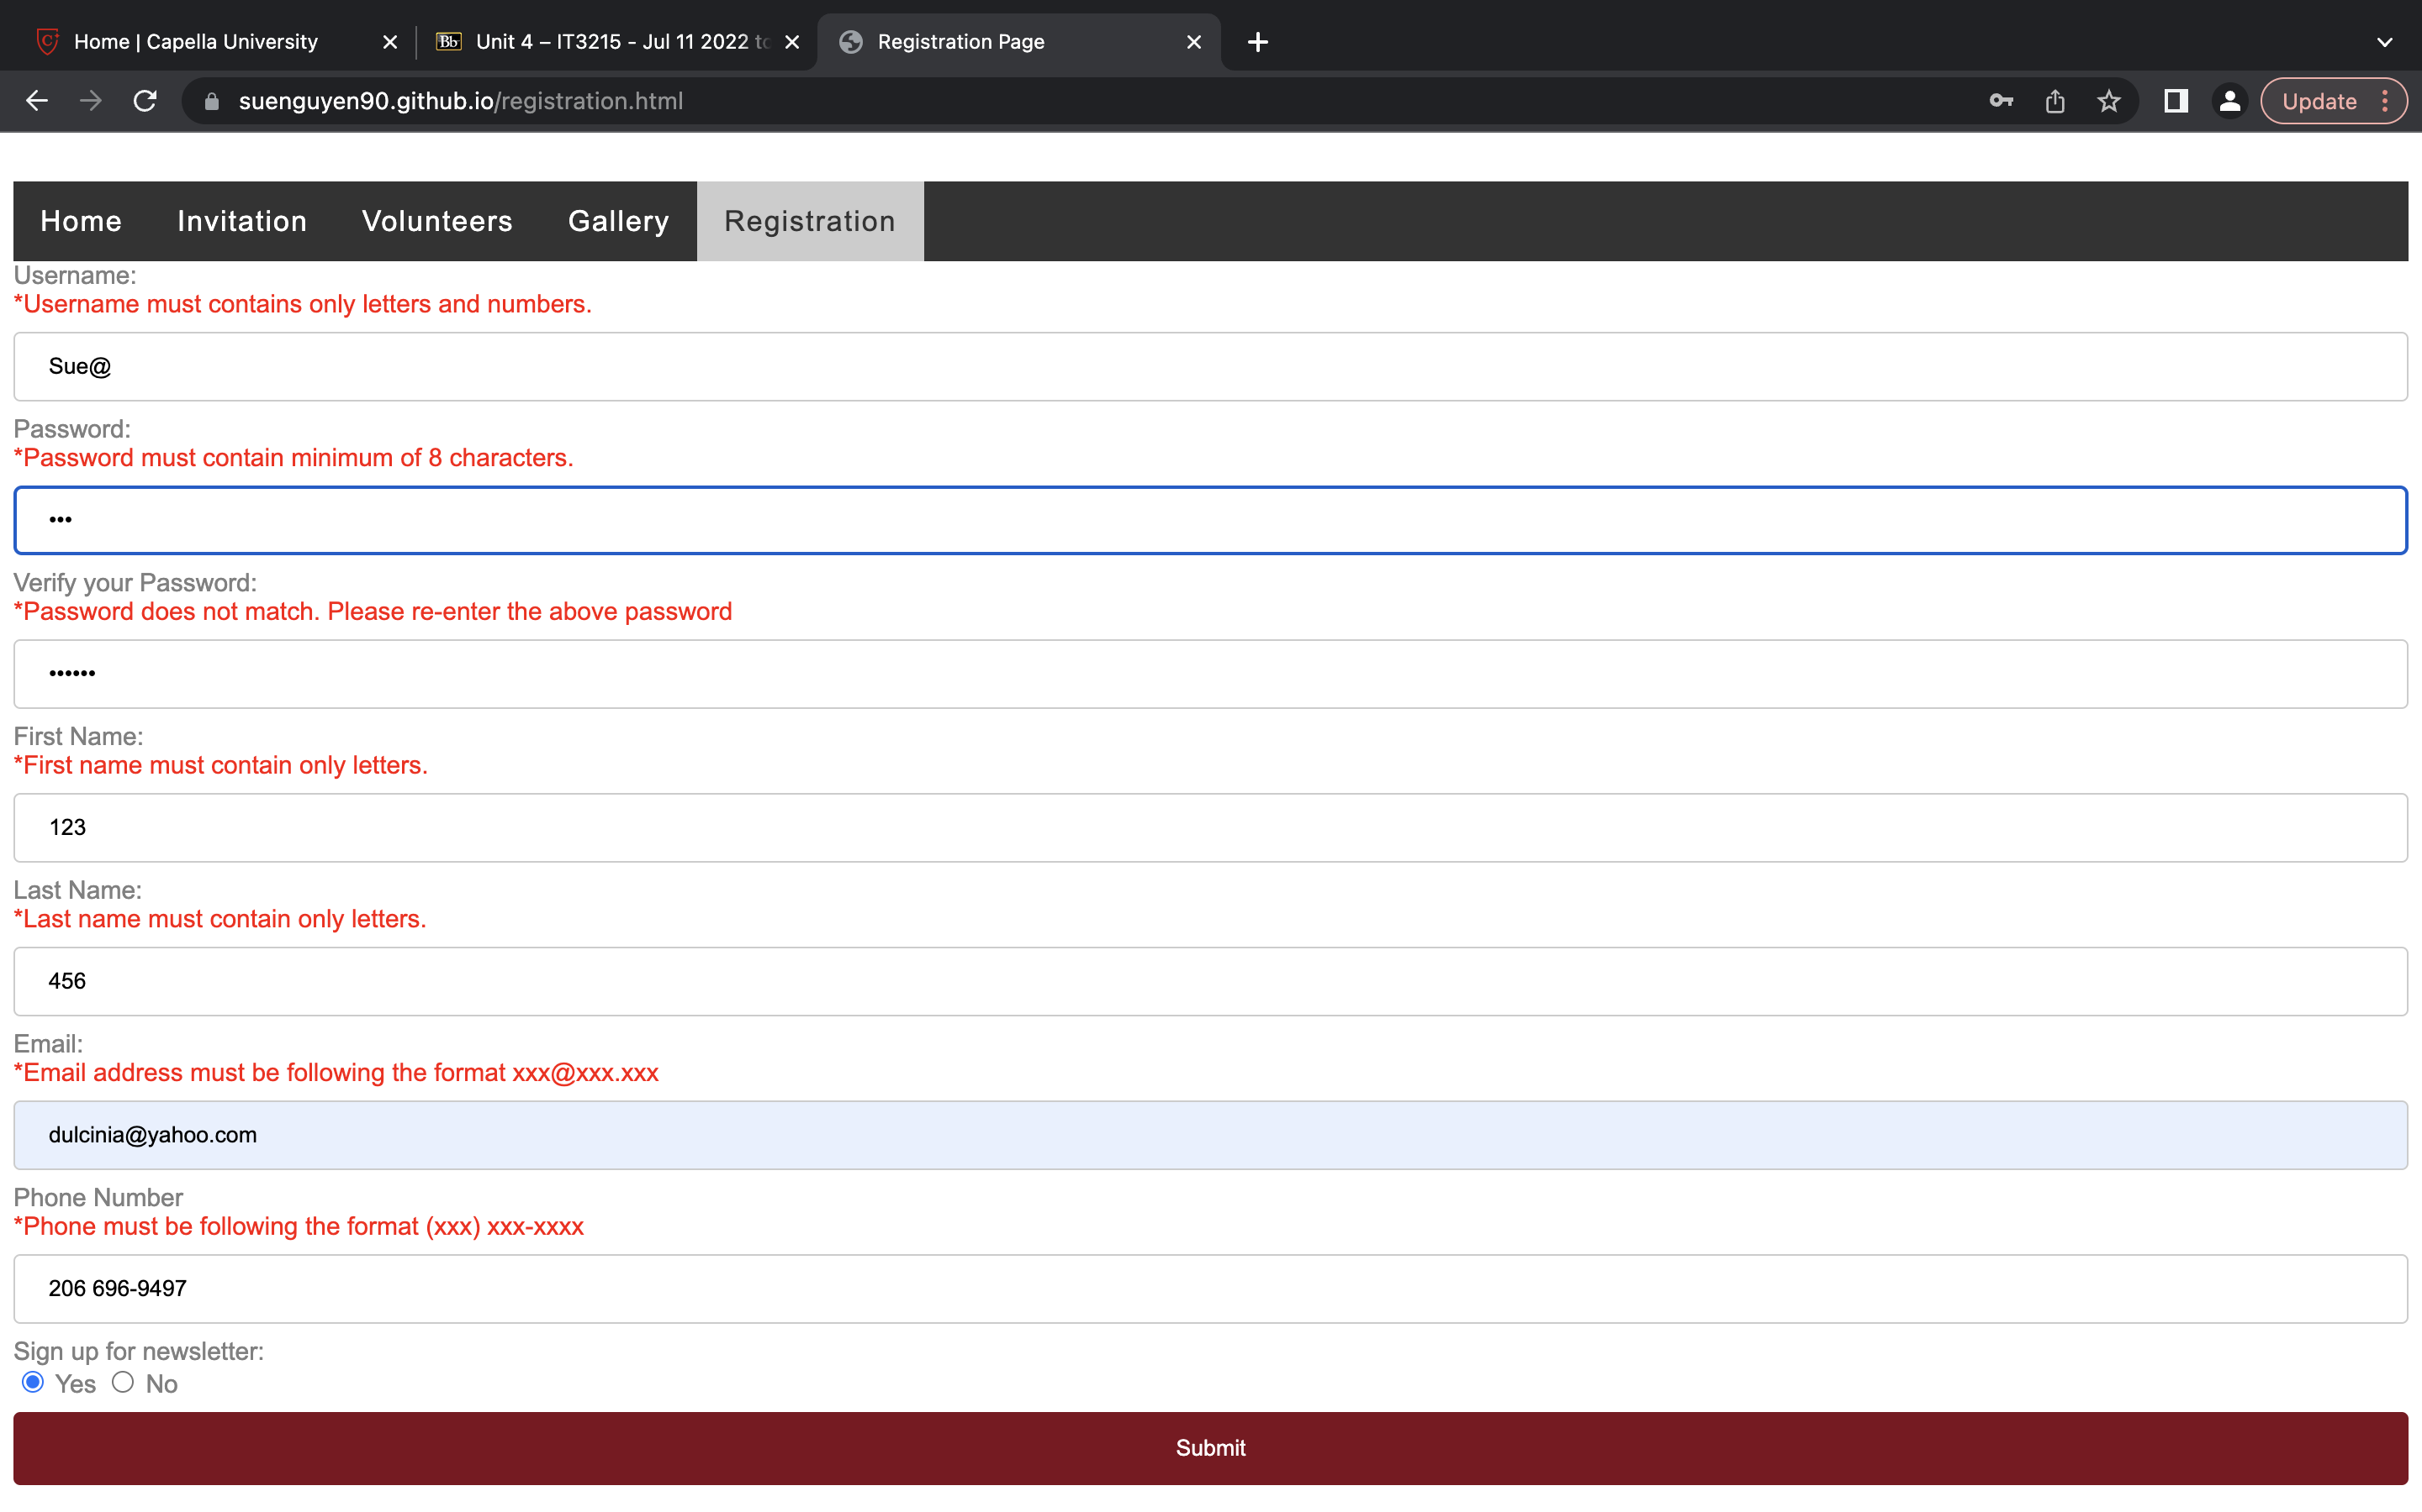

Screen cap for cursor to be on the first error field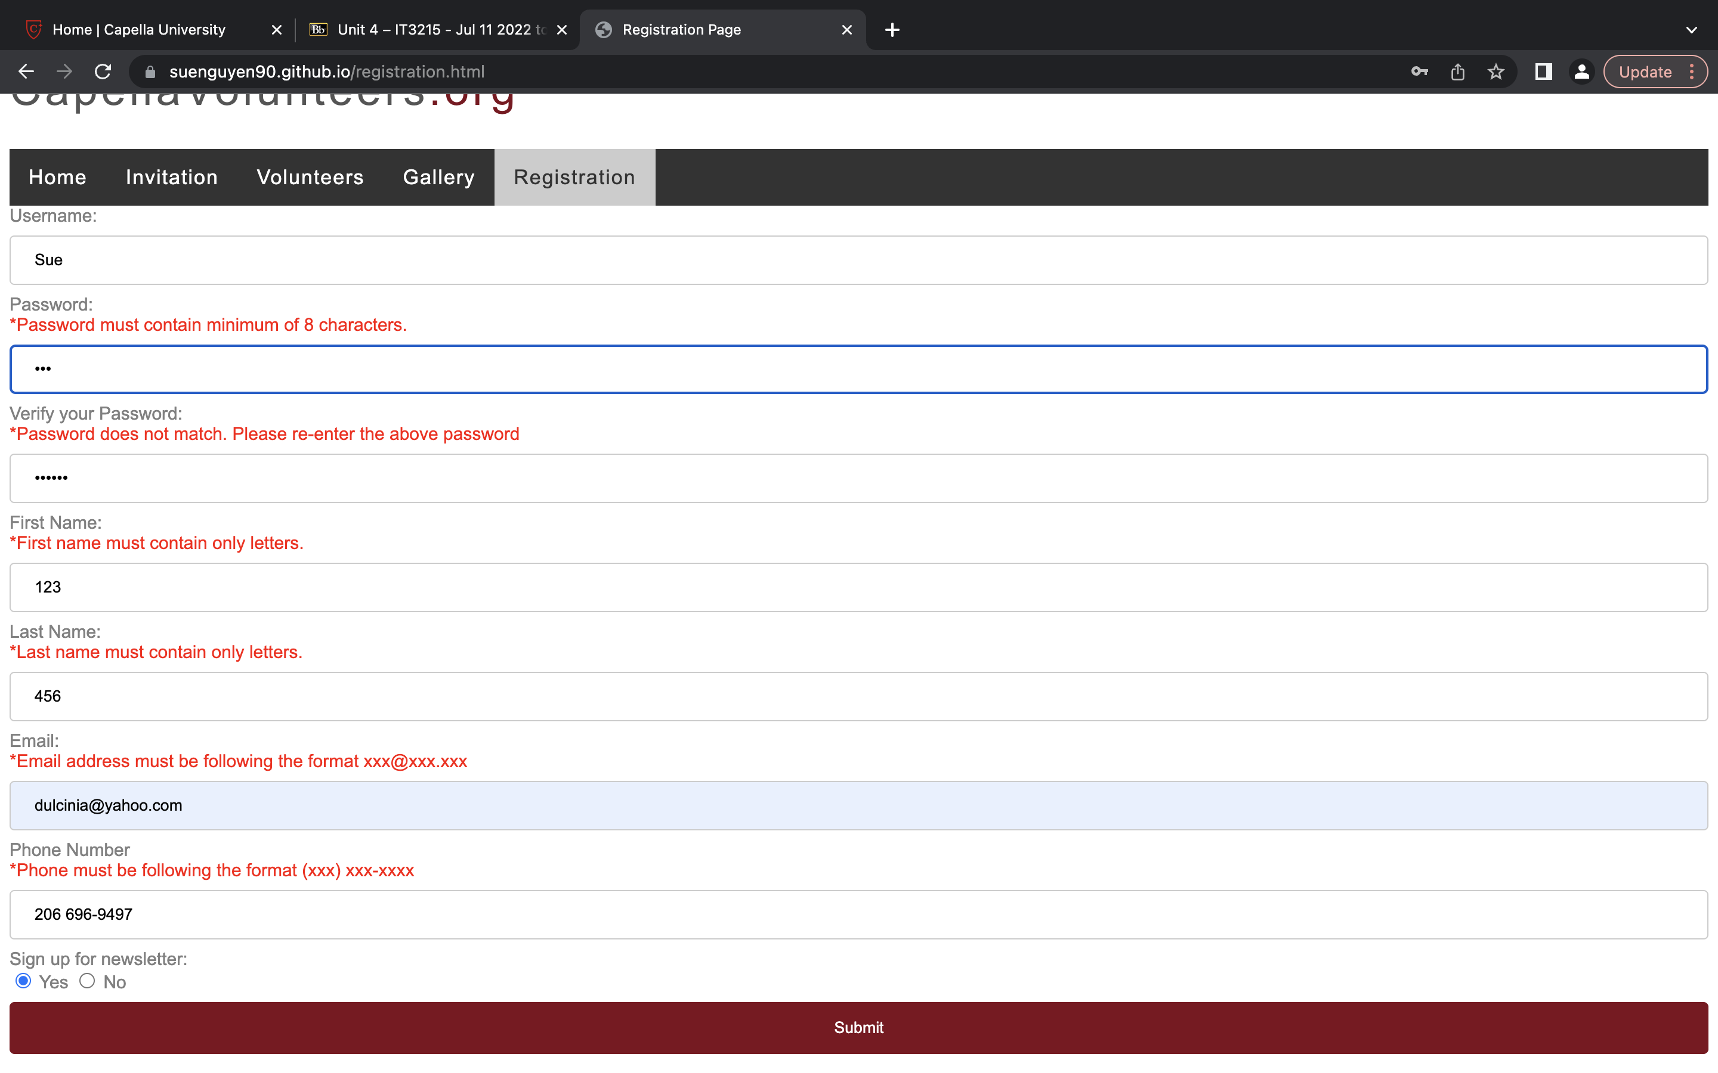

Website

<https://suenguyen90.github.io/registration.html>

I’ve tested on two browser google chrome and safari for codes error free.